Whiskers Wellness Spa
Take-home Coding Assignment – Normalization
Weight: 10% of final grade
Due: September 25, 2026

Instructions
In this assessment, you will demonstrate the normalization process.
For each view:
- Show initial table, 1NF, 2NF, and 3NF as demonstrated in class
- Primary Keys are to be marked with PK
- Foreign Keys are to be marked with FK
Then, merge the entities from the three views and create a final merged ERD. (3 marks)

Submission
Submit a single Word document “TH1_LastName_FirstName.docx” to Brightspace.
It is your responsibility to ensure your work is submitted on or before the due date/time.
Late submissions will not be accepted.

Coding Standards
Only those database programming methods, practices, and techniques taught in class, or available from Brightspace Word documents and/or exercises, will be permissible in SDEV1201 assignments and quizzes. Any solution in a take home assignment or in an in-class quiz submission using non-approved methods, practices, and/or techniques, or code that is not executable in the instructor designated environment, will be given a mark of zero.
This is an independent assessment: any academic misconduct including collaboration, duplicate submissions, or the use of generative AI will be addressed as per the Academic Integrity policy and may result in a mark of zero.

The Company

Whiskers Wellness Spa has hired your team to design a database that will support its daily operations of their dog spa. The business currently relies on various reports to manage bookings, services, employees, and customer payments. These reports are provided below and will serve as the starting point for the normalization and database design process.

Payment History View (6 marks)
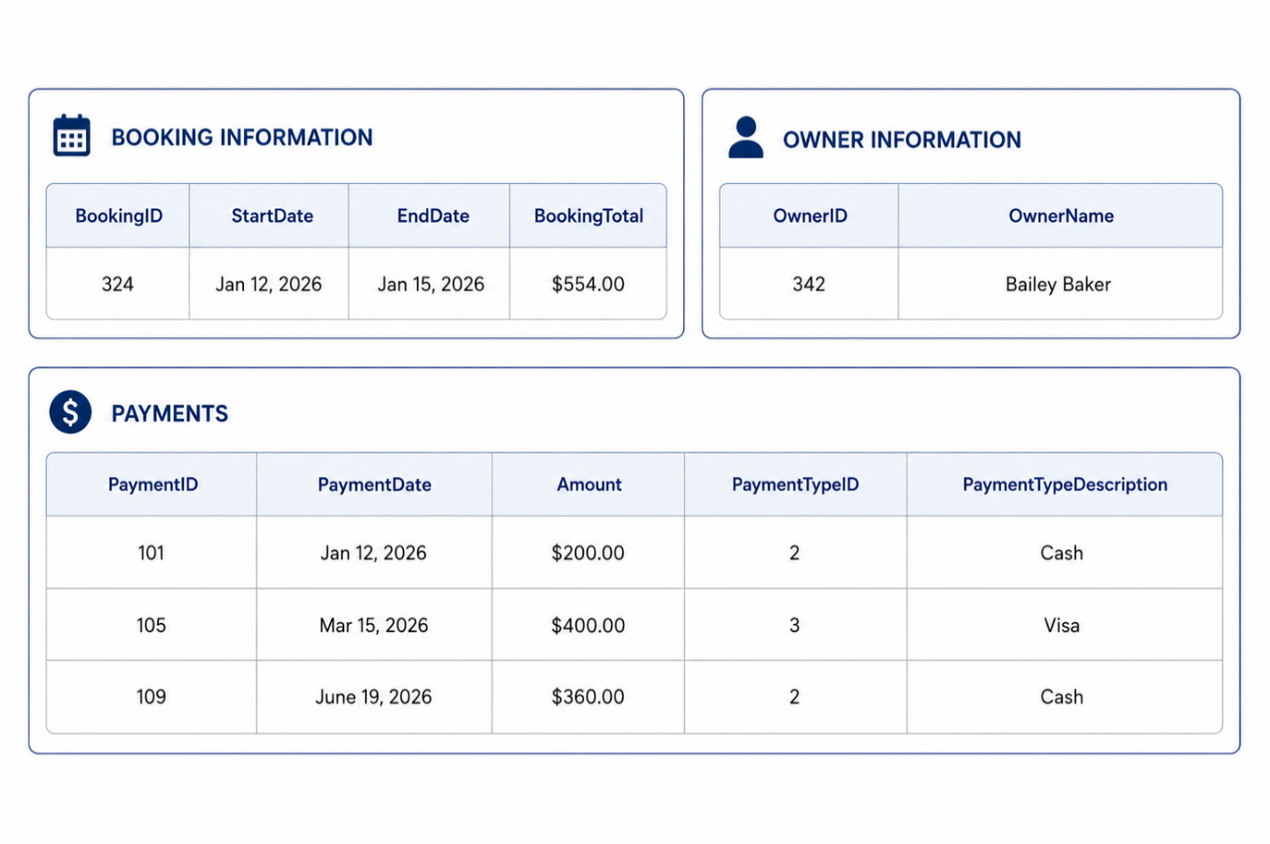
Additional Notes:
- Booking can be paid over multiple payments
- PaymentID uniquely identifies a payment
- BookingID, OwnerID, PaymentID, and PaymentTypeID are all unique

Employee Service History View (6 marks)
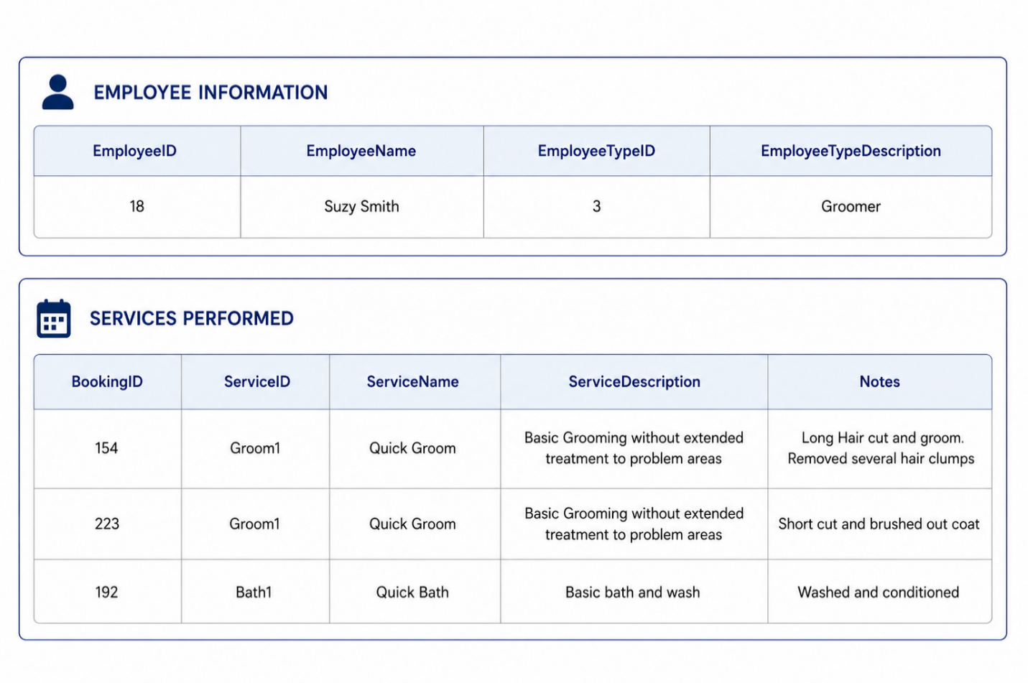
Additional Notes:
- An employee can be associated with many service types
- Each booking may include a service only once
- Notes describing the work performed are stored for each service completed as part of a booking
- EmployeeID, EmployeeTypeID, BookingID, and ServiceID are all unique

Booking Invoice View (7 marks)

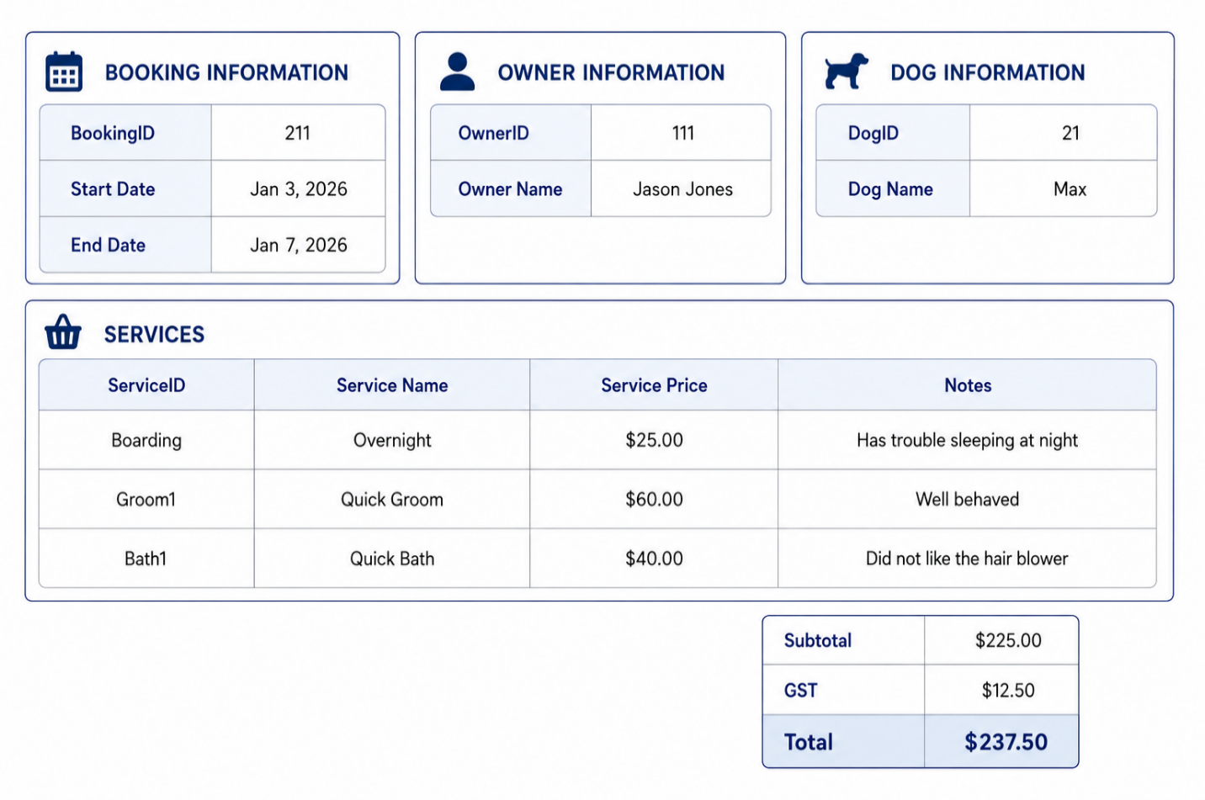

Additional Notes:

- Each booking record relates to a single dog
- A booking can have many services provided
- At least one night of boarding must be included with every booking
- The boarding service rate represents the cost for one night of accommodation
- BookingID, OwnerID, DogID, and ServiceID are all unique

